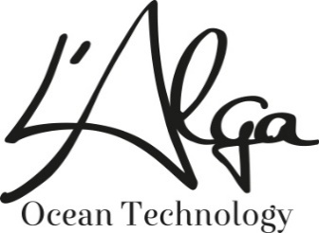

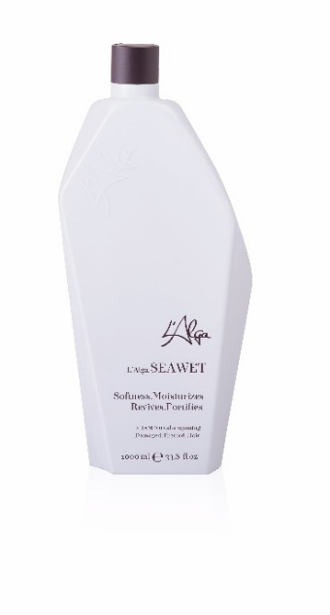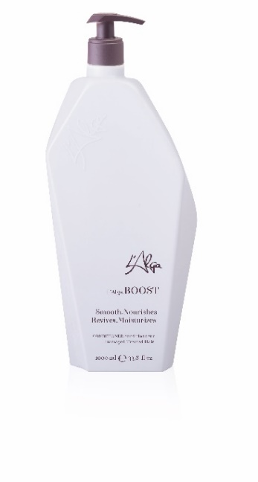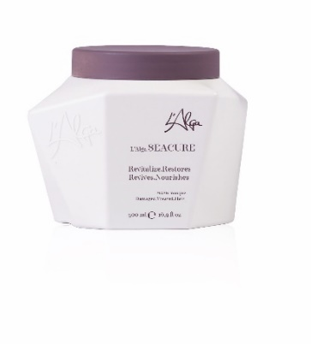
SALON BACK BAR USE WILL LEAD TO
EXTRA SALE TO CUSTOMERS
THAT'S WHY PROMOTE L'ALGA:
SEAWET SHAMPOO 1000ML
BOOST CONDITIONER 1000ML
SEACURE MASK 500ML

PURCHASE:
60 + 15 FREE = SAVING 20%
90 + 30 FREE = SAVING 25%
120 + 60 FREE = SAVING 33,3%

Valid till 15 February 2020.
Order need to be received before 16 February 2020.

Promo price €15,00
Saving 12,3% on promo price. Srp €55,00

Promo price €15,00
Saving 11,7% on promo price. Srp €55,00

Promo price €13,20
Saving 11,8% on promo price. Srp €48,00

Promo price €29,72
Saving 26,6% on promo price

Promo price €14,00
Saving 12,1% on promo price. Srp €49,95

The last 25 L’Alga Winter Bag
special promotion price

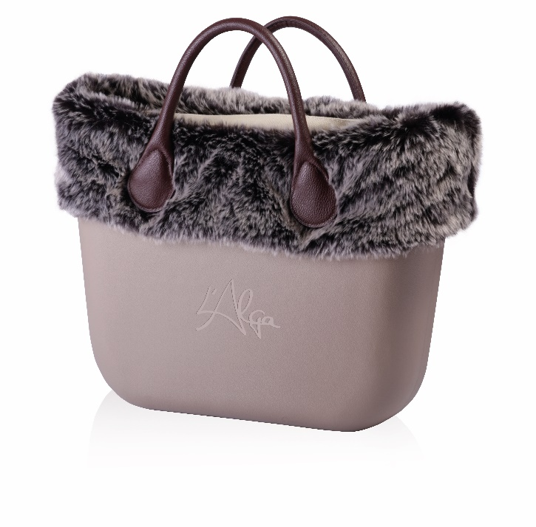
L’Alga Winter bag (with the fur) including:
1 x SeaWet Shampoo 250ml
1 x SeaCure Mask 250ml
1 x SeaLush Serum 100ml
1 x Boost Conditioner 10ml
Regular Distributor price $ 61.60 including bag.
Promo discount 32.5% - $ 20.00
Your price $ 41.60 including bag.

Promotional SRP $99 - $110

Valid till 1 February 2020 as long as stock last.
First in first out with orders.

The last 65 L’Alga Summer Bag
special promotion price for you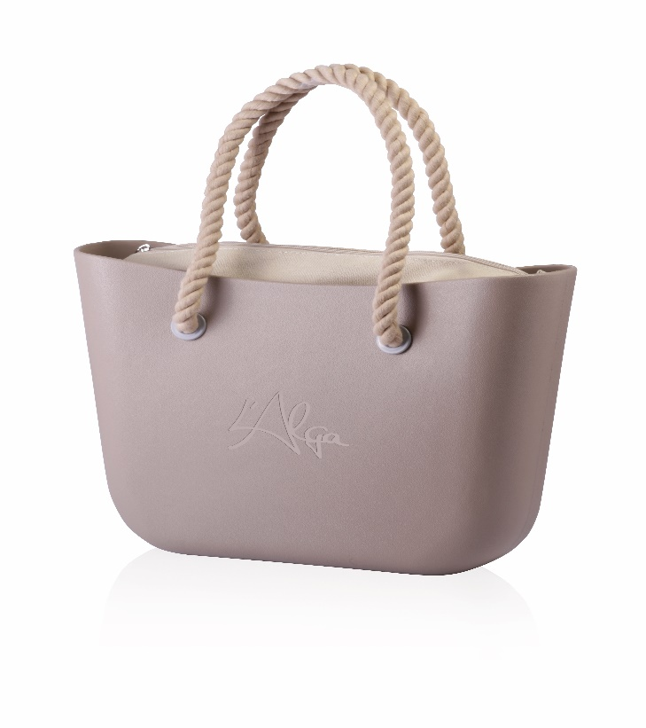
L’Alga Summer Bag including:
1 x SeaWet Shampoo 250ml
1 x Boost Conditioner 250ml
1 x SeaMist Spray 100ml
1 x SeaCure Mask 15ml
1 x SeaLush Serum 3ml

Regular Distributor price $ 52.43 including bag.
Promo discount 30% - $ 15,72
Your price $ 36.71 including bag.

Promotional SRP $90 - $105

Valid till 1 February 2020 as long as stock last.
First in first out with orders.

